**Name – Tanishq Thuse**

**Branch – CSAI**

**Div – B**

**Roll no. – 52**

**Subject – Computer Network**

# Assignment 1: Installing VMware on Laptop

VMware Fusion is a virtualization software that allows users to run multiple operating systems on macOS.

1. Step 1: Open the official VMware website: https://www.vmware.com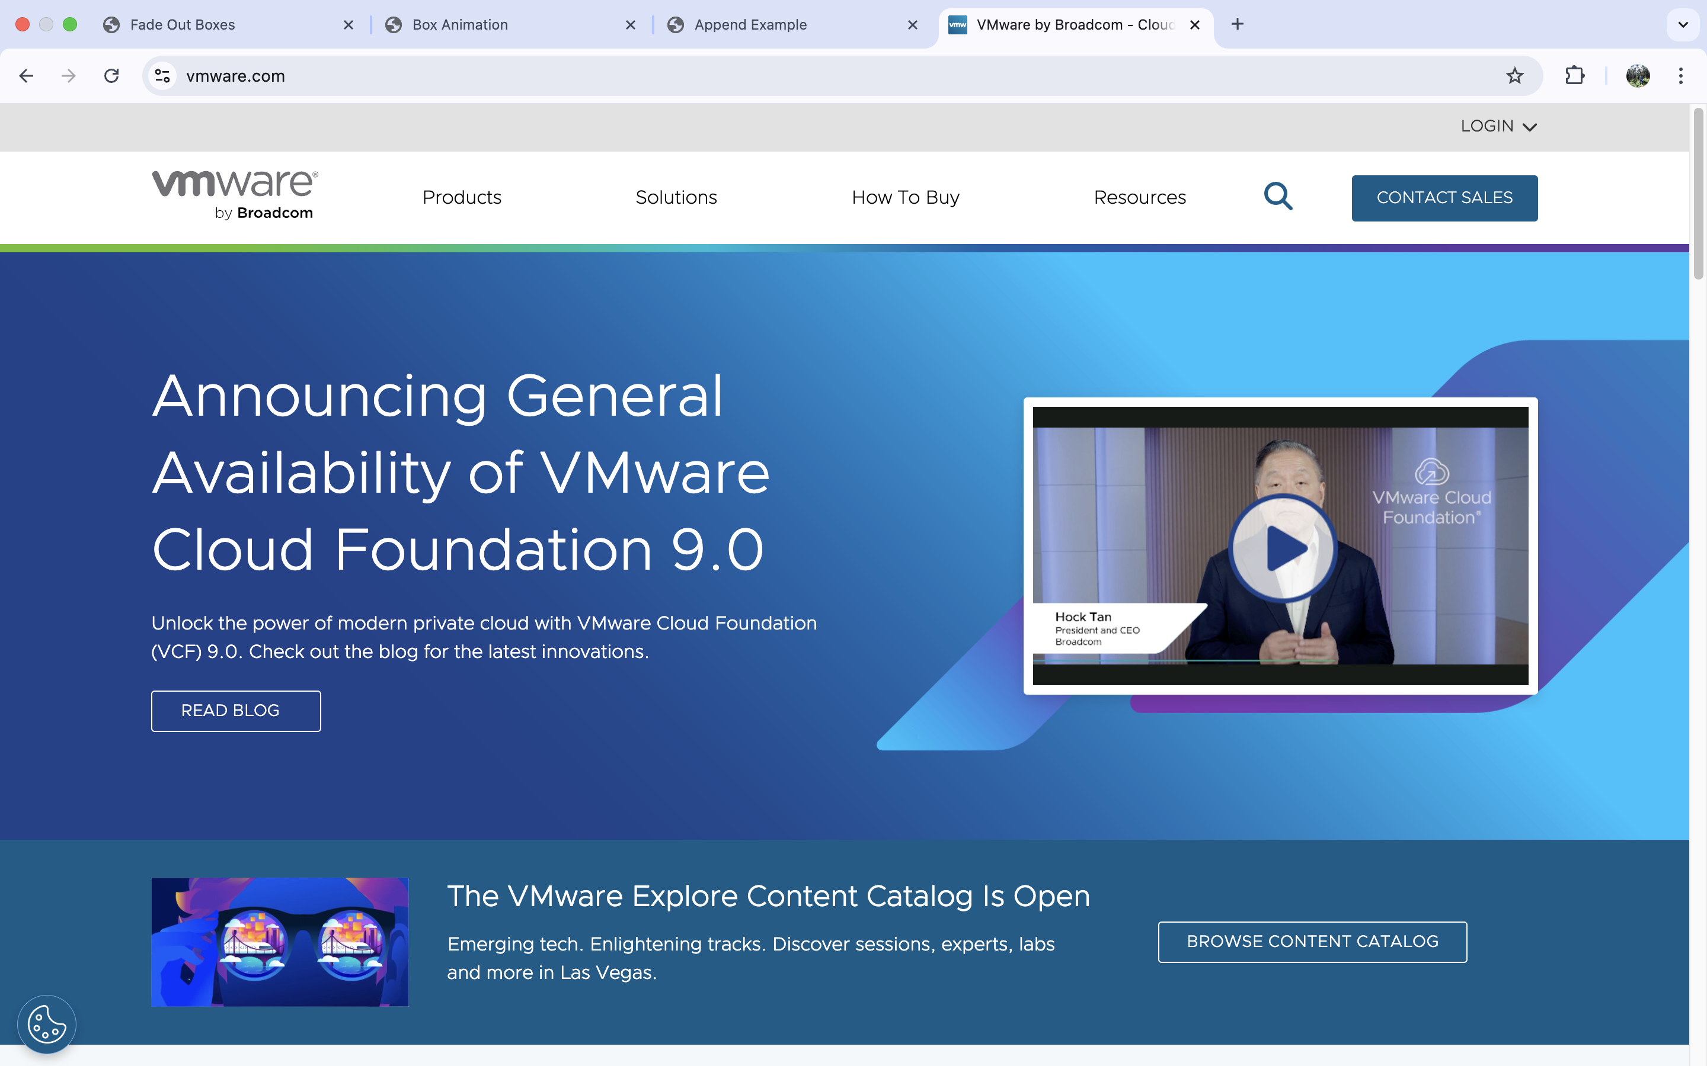
2. Step 2: Navigate to the 'Downloads' section and choose 'VMware Fusion' for Mac.
3. Step 3: Select the desired version (VMware Fusion Player for personal use is free) and click on 'Download Now'.
4. Step 4: Once the DMG file is downloaded, locate it in your Downloads folder and double-click to open it.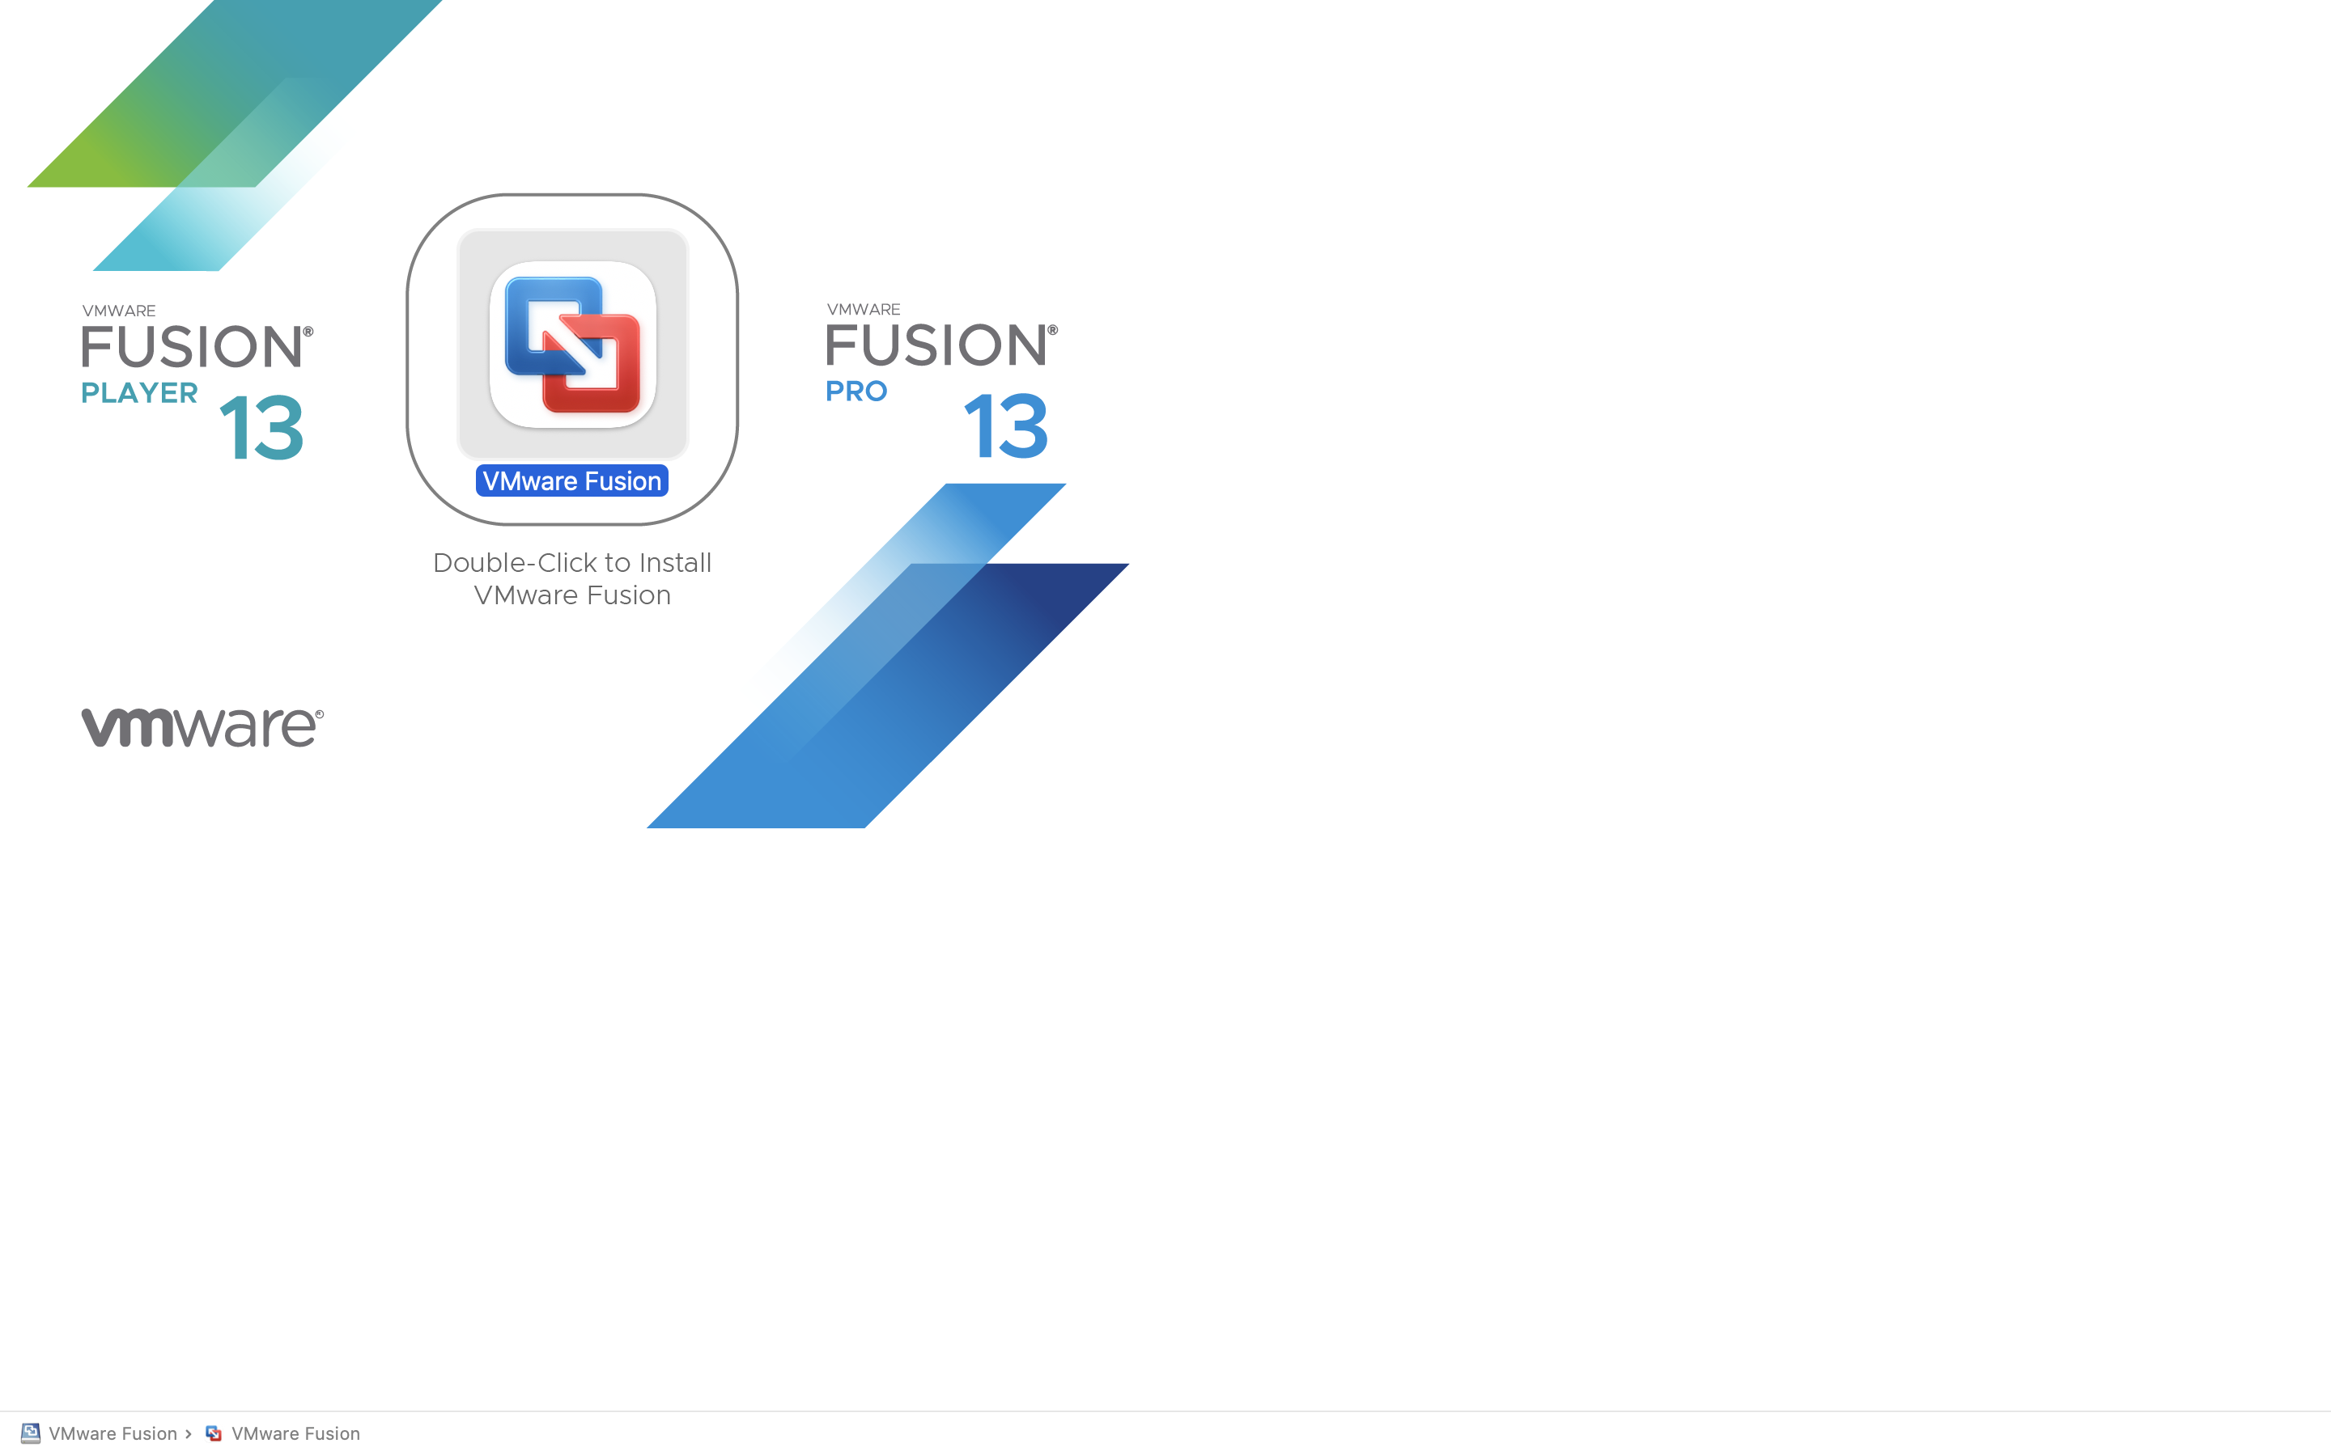
5. Step 5: Drag the VMware Fusion icon into the Applications folder as instructed on the installer screen.
6. Step 6: After installation, go to Applications and open VMware Fusion.
7. Step 7: Accept the license agreement and, if prompted, enter your Mac administrator password to continue. 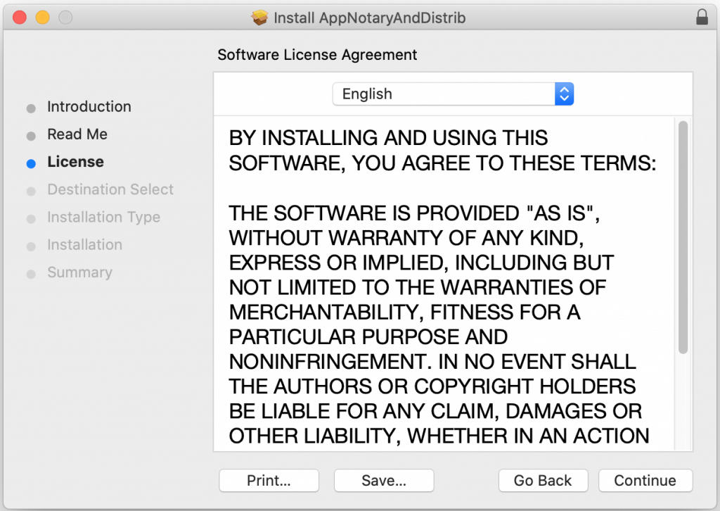
8. Step 8: Enter the license key (if you have one) or continue using the free version if applicable. 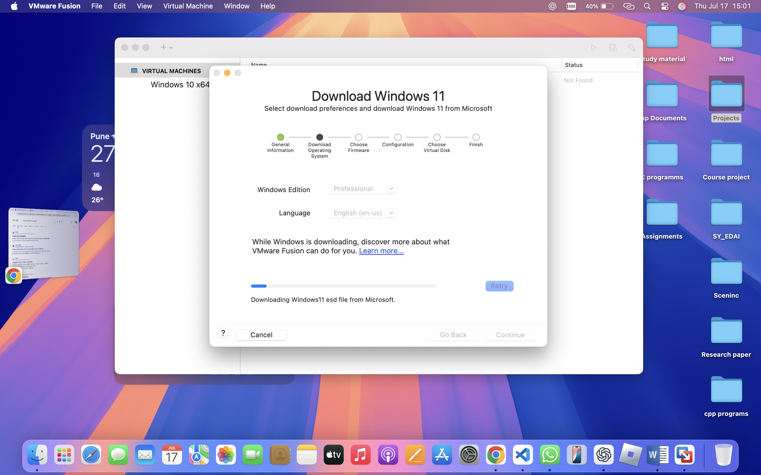
9. Step 9: VMware Fusion is now installed and ready to create or import virtual machines. 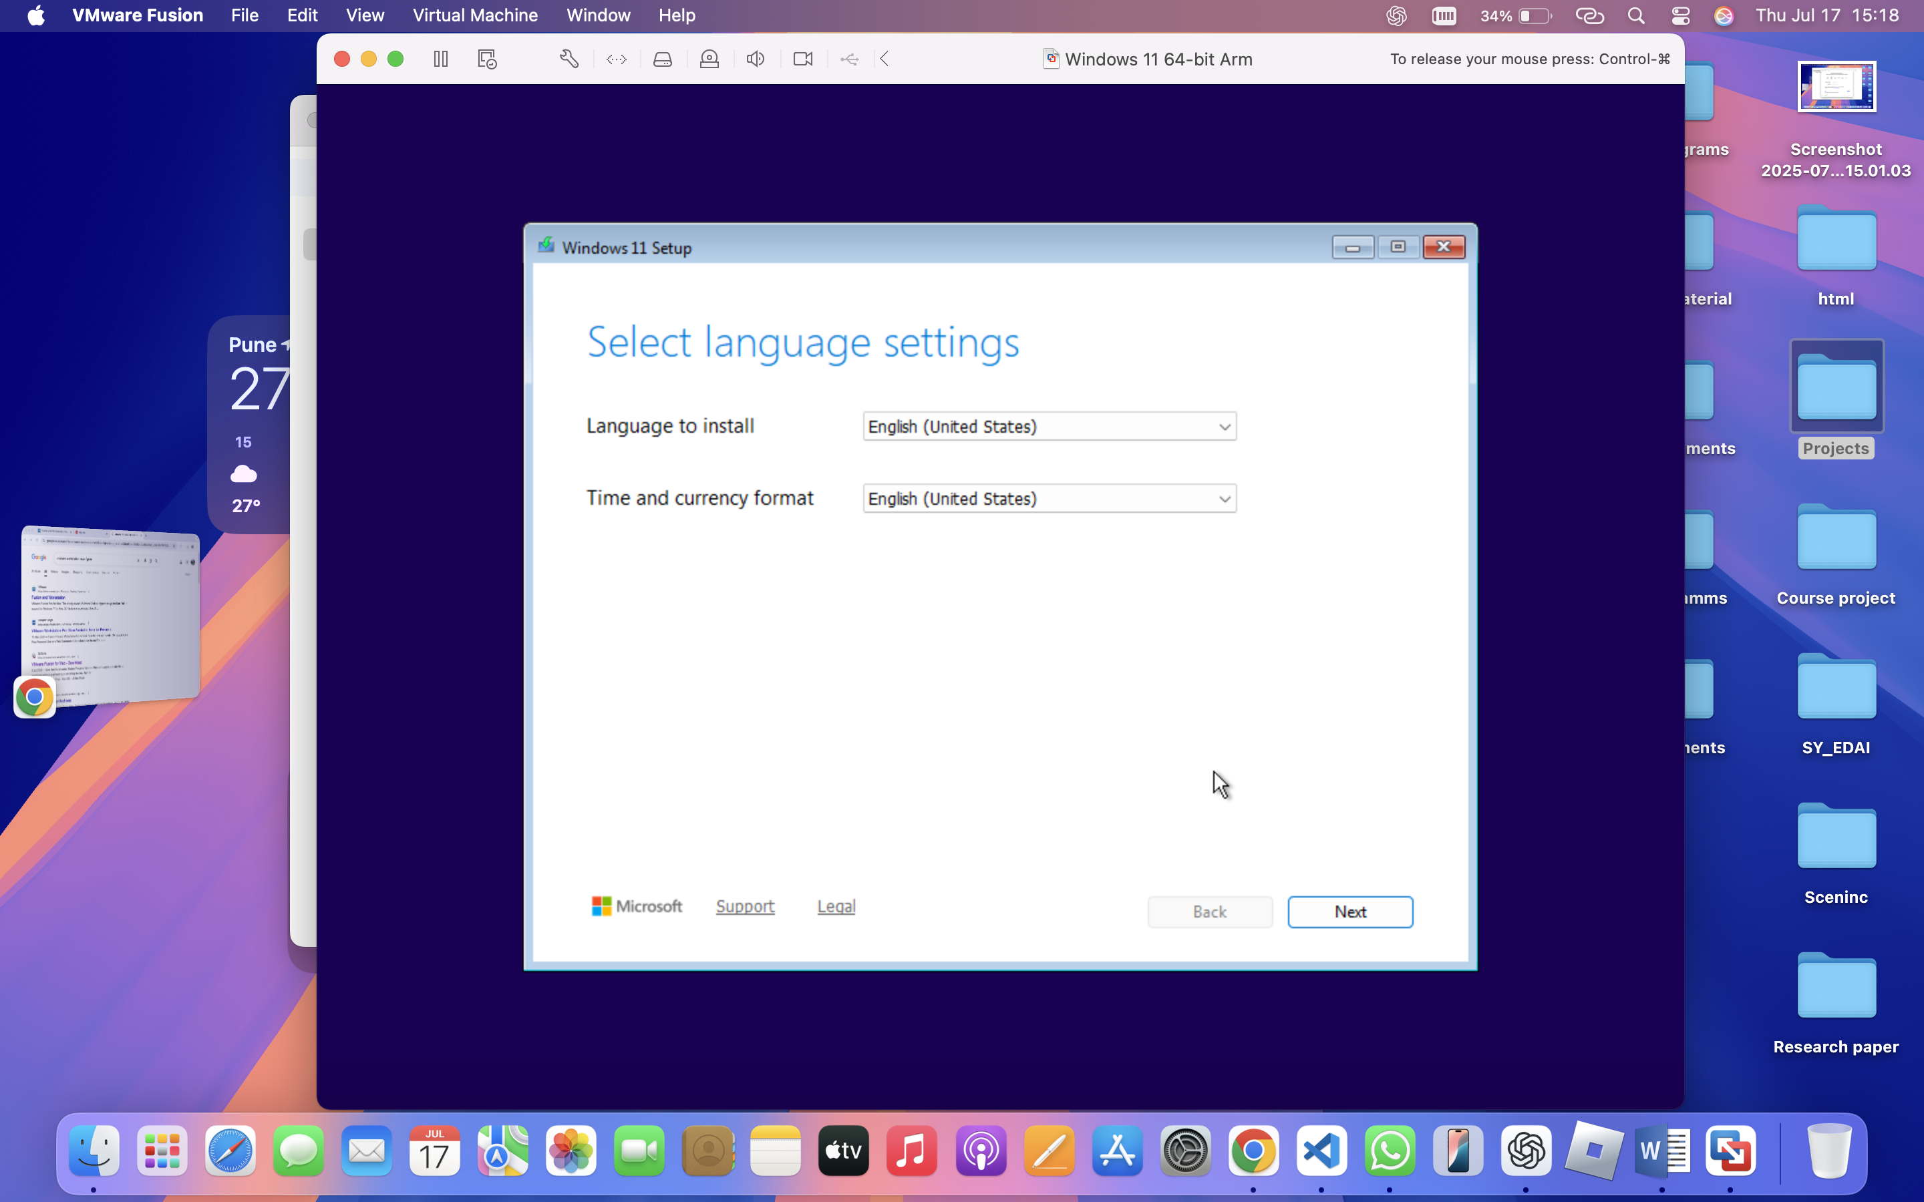

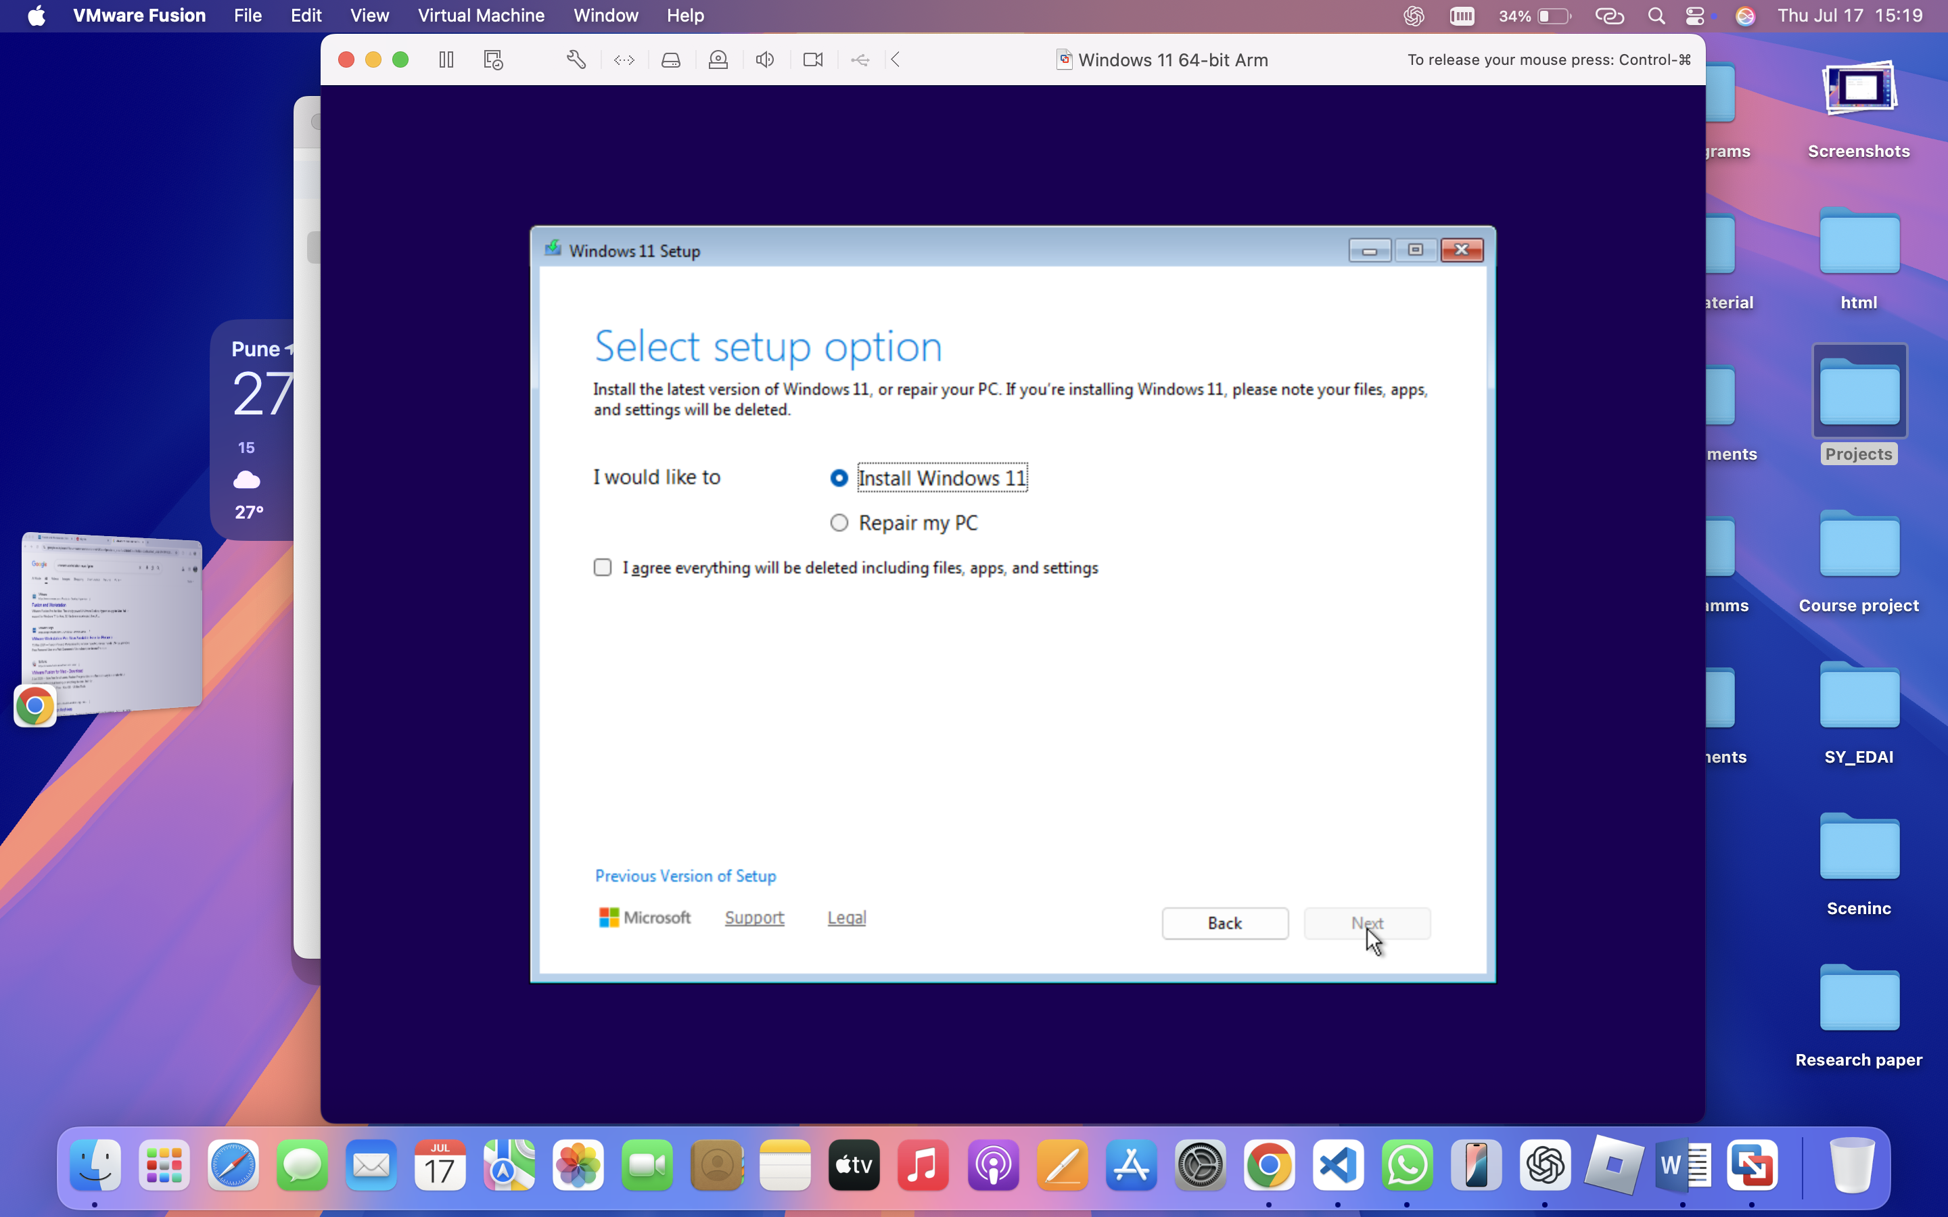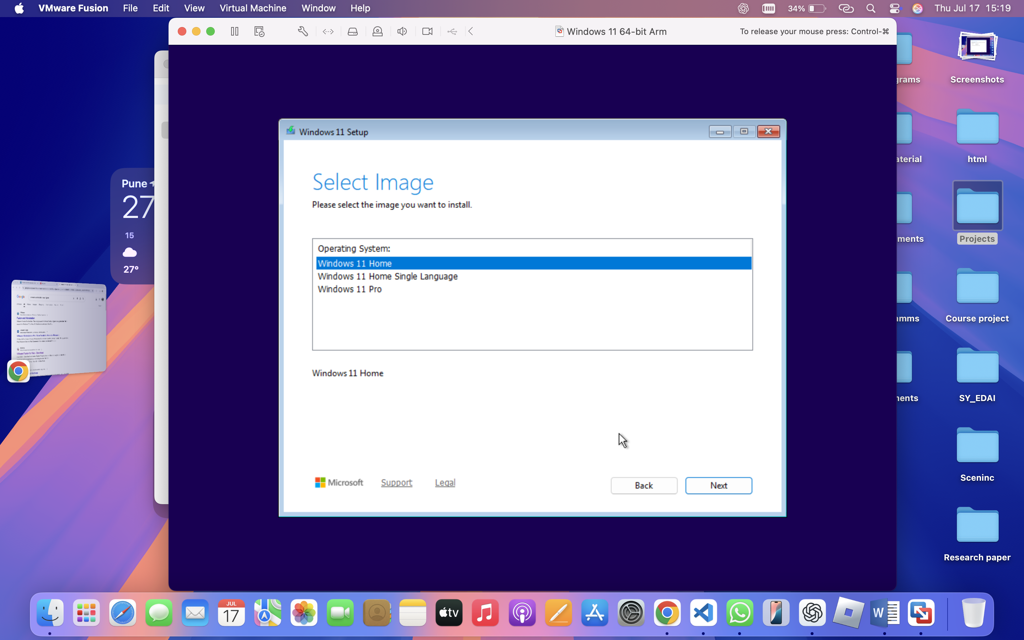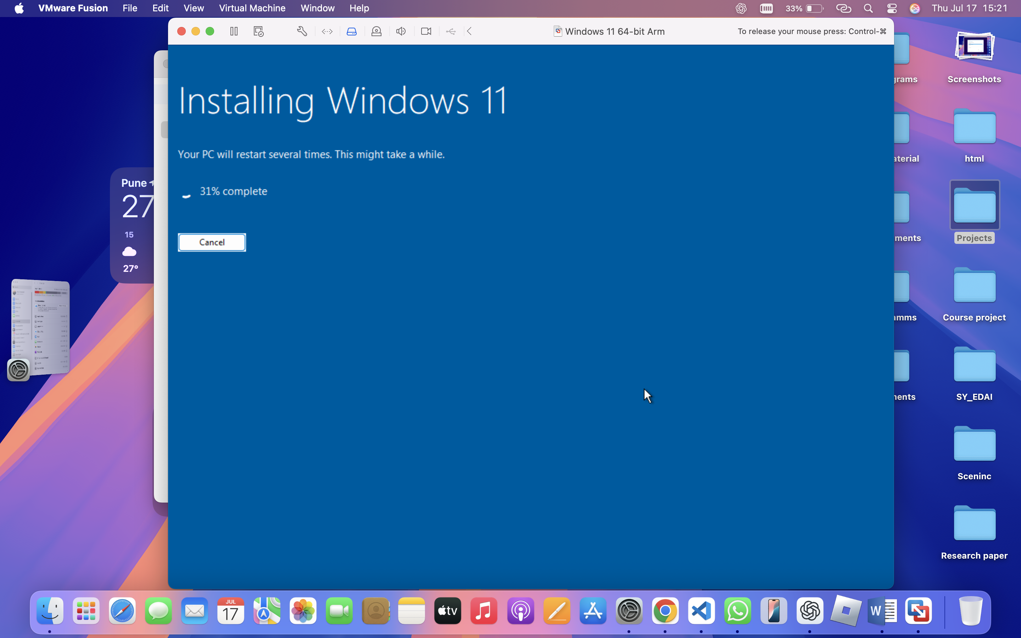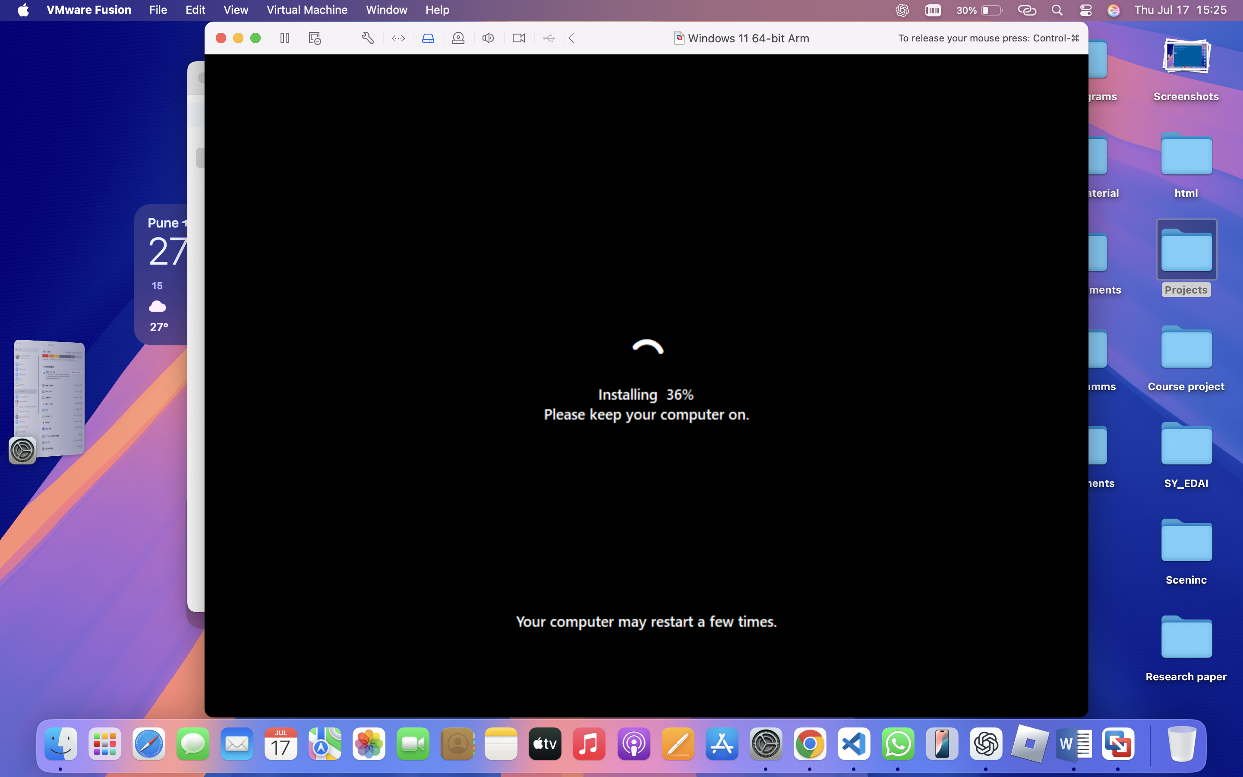Following these steps will successfully install VMware Fusion on your Mac, enabling you to run virtual machines for development, testing, or learning purposes.

